Remote Controlled Trailer Jack
by
Jacob Thaxton, Mark Halter, Shubh Shahra, & Kanisha

A Senior Project Report Submitted to the
EECS Faculty, University of Toledo

Faculty Advisor: Dr. Daniel Georgiev

April 2026

TABLE OF CONTENTS
Abstract....................................................................................................................... 1
1. Problem Statement................................................................................................. 2
1.1. Need.......................................................................................................................... 2
1.2. Objective................................................................................................................... 2
1.3. Background............................................................................................................... 2
1.4. Needs Identification ................................................................................................. 2
1.4.1 Marketing Requirements ............................................................................ 2
1.4.2 Objective Tree............................................................................................. 3
1.4.3 Ranked Needs.............................................................................................. 3
2. Requirements Specifications................................................................................. 4
2.1 The Requirements...................................................................................................... 4
2.1.1 Engineering Requirements.......................................................................... 5
2.1.1.1 Engineering Requirement # 1....................................................... 5
2.1.1.2 Engineering Requirement # 2....................................................... 6
2.1.1.3 Engineering Requirement # 3....................................................... 7
2.1.1.4 Engineering Requirement # 4....................................................... 8
2.1.1.5 Engineering Requirement # 5....................................................... 9
2.1.1.6 Engineering Requirement # 6...................................................... 10
2.2 Constraints................................................................................................................. 11
2.3 Standards................................................................................................................... 11
3. Hardware Design.................................................................................................. 12
3.1 Design Choices.......................................................................................................... 12
3.2 Level 0………........................................................................................................... 12
3.3 Level 1………........................................................................................................... 13
3.4 Bill of Materials.......................................................................................................... X

4. Software Design.................................................................................................... X
5. Design Verification............................................................................................... X
5.1 Component Unit Testing……….............................................................................. X
5.2 System Testing………............................................................................................. X
5.2.1 Full-Scale Trailer Testing……….............................................................. X
5.2.2 Mock Trailer Testing………..................................................................... X
5.3 Engineering Target Evaluation………..................................................................... X
6. Project Schedule................................................................................................... X
6.1 Gantt Chart………................................................................................................... X
7. Summary and Conclusions.................................................................................. X
7.1 Summary………...................................................................................................... X
7.2 Future Improvements………................................................................................... X
8. References............................................................................................................. X

FIGURES
Figure 1: Objective Tree............................................................................................................... 4
Figure 2: Level 0 Diagram.......................................................................................................... 10

TABLES
Table 1: Marketing Requirements to Engineering Requirements Mapping................................. 4
Table 2: Design Choices.............................................................................................................. 12
Table 2: Level 0 RC Trailer Jack................................................................................................. 10
Table 3: Level 1 Microcontroller................................................................................................. 11
Table 4: Level 1 Mobile Device.................................................................................................. 11
Table 5: Level 1 Motor Controller............................................................................................... 11
Table 6: Level 1 Power Supply.................................................................................................... 11
Table 7: Level 1 Step-Down Voltage Converter.......................................................................... 11
Table 8: Level 1 Motors and Wheels........................................................................................... 11
Table 9: Level 1 Relay……….....................................................................................................
Abstract
The purpose of our project is to address the frustration of parking, positioning, and hitching a trailer by replacing the manual labor of trailer positioning with a motorized jack system. This system will be wirelessly controlled by the user utilizing a mobile application installed on their smartphone, and it will operate at low speeds to ensure user safety.

- Problem Statement

  - Need
Trailer owners often struggle with manual parking, positioning, and connecting to their trailers. Environmental factors such as often limit vehicle maneuverability, adding to the difficulty.

  - Objective
Our objective is to design and construct a remotely controlled, electronically driven trailer jack to reduce the physical labor of moving a trailer. This device will be remotely controlled by the user using a smartphone application.

  - Background
Most trailer jack users report frustration when positioning and moving their trailers due to many factors such as tight spaces, physical difficulty, and spotter requirement. Many users claim they are physically unfit to be moving the trailer, and they wish the process did not require so much physical labor. Users also reported claims of frustration when moving a trailer in very tight spots that their vehicle has difficulty navigating. Our findings are based on the personal experience of our team and our associates. We were unable to conduct a proper survey due to the unfortunate need to switch our project in the middle of the academic year.

1.4 Needs Identification
1.4.1 Marketing Requirements
The system should:
- Only require a single person to operate
- Be intuitive and easy to use
- Possess real-time control and responsiveness
- Be compatible with standard jack interface
- Be affordable and sustainable for the average consumer

1.4.2 Objective Tree
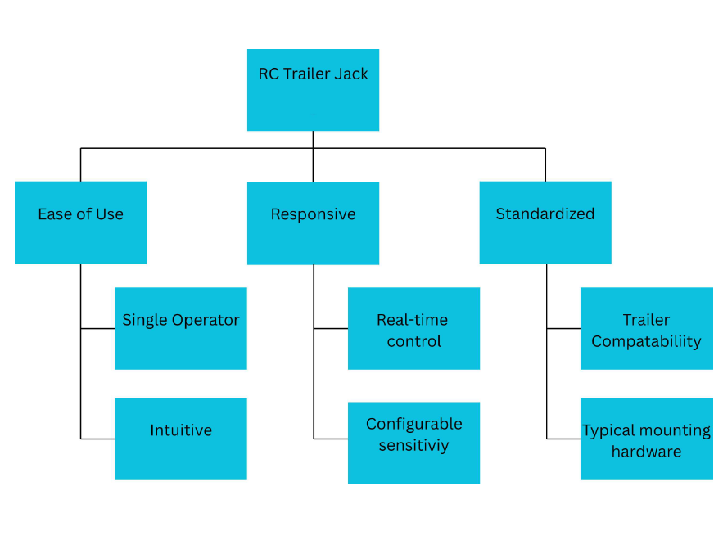
Figure 1: Objective Tree
1.4.3 Ranked Needs
 | Ease of Use | Responsive | Standardized | Overall Score
Ease of Use | - | 1 | 1 | 2
Responsive | 0 | - | 1 | 1
Standardized | 0 | 0 | - | 0
Table 1: Pairwise Comparison Matrix - General
Rationale: Since our project goal is to replace manual labor, “Ease of Use” has priority

 | Single Operator | Intuitive | Overall Score
Single Operator | - | 1 | 1
Intuitive | 0 | - | 0
Table 2: Pairwise Comparison Matrix - Ease of Use
Rationale: Since our project goal is to replace manual labor and reduce spotters, “Single Operator” has priority

 | Real-Time Control | Configurable Sensitivity | Overall Score
Real-Time Control | - | 1 | 1
Configurable Sensitivity | 0 | - | 0
Table 3: Pairwise Comparison Matrix - Responsive
Rationale: “Real-time control” prioritizes user safety and satisfaction, so it takes priority

 | Trailer Compatibility | Typical Mounting Hardware | Overall Score
Trailer Compatibility | - | 1 | 1
Typical Mounting Hardware | 0 | - | 0
Table 4: Pairwise Comparison Matrix - Standardized
Rationale: While both are important, our product should be compatible with most trailer types, increasing our market. That is why “Trailer Compatibility” has priority

- Requirements Specifications

2.1 The Requirements
Marketing Requirement | Engineering Requirement | Rationale
Requires only one operator | Product must be able to move a trailer at a speed of approximately 1 mph. | A movement speed of 1 mph lets the user operate and control the trailer safely without the need of a spotter(s).
Real-time control and responsiveness | The microcontroller should be able to communicate with the smart phone with maximum range of at least 30ft. | A 30 ft range allows our system to maintain real-time control and responsiveness without delays due to distance.
Compatible with standard jack interface and various trailers | Product must be able to bolt up to straight tongue trailers and capable of storage during vehicle towing. | This allows for immediate swap to our product without requiring additional alteration to the trailer.
 | Trailer jack must be able to move a trailer with a load of at least 500lb. | The trailer must be able to move a trailer with a load for the product to meet its goal.
Affordability and Sustainability | Requires a power supply of 12VDC. | Low voltage requirement allows for cheaper production.
 | Operation at a continuous duty cycle of at least 10mins. | Allows our product to operate for long periods of time, increasing the value of the product for the price.
Table 5: Marketing Requirements to Engineering Requirements Mapping

2.1.1 Engineering Requirements
2.1.1.1 Engineering Requirement #1
Engineering Requirement # : | 5

The Requirement:
Trailer jack must be able to move a trailer with a load of at least 500lb.

Importance (1 = lowest, 5=highest): | 1

Impacted Marketing requirements (list numbers): | 3

Category (select all that apply):
adaptability
functionality
political
availability
reliability
budget
safety
documentation
look and feel
social
economic (sales cost)
maintainability
energy
manufacturability standards
environmental impact
operational (constraints of environment)
sustainability
ergonomics
usability
ethical performance
other ___________

Justification: Describe the rationale for this requirement. Why is this requirement needed? Why is it
reasonable to expect it can be achieved?
This is an essential requirement because the tongue load of a typically ranges from 10% to 15% of the trailer's total loaded weight. If our product is to successfully move a trailer with a load of 2000 lbs, we need to

Testability/Verification: Describe the process your team will use to verify the requirement.
We will test the product on a trailer with a several rated longue loads, ranging from 200-600 lbs. We will evaluate the maneuverability of the trailer at these loads.

History. If you change a requirement, indicate date of change, reason, and list the previous version of the requirement.
This requirement was established on 01/19/2026.

2.1.1.2 Engineering Requirement #2
Engineering Requirement # : | 2

The Requirement:
Trailer jack must be able to move a trailer at a speed of approximately 1 mph.

Importance (1 = lowest, 5=highest): | 4

Impacted Marketing requirements (list numbers): | 1

Category (select all that apply):
adaptability
functionality
political
availability
reliability
budget
safety
documentation
look and feel
social
economic (sales cost)
maintainability
energy
manufacturability standards
environmental impact
operational (constraints of environment)
sustainability
ergonomics
usability
ethical performance
other ___________

Justification: Describe the rationale for this requirement. Why is this requirement needed? Why is it
reasonable to expect it can be achieved?
A movement speed of 1mph allows the user to operate the product at a safe speed without the need of a spotter(s). This is a low speed goal, so the torque requirement is reasonable for the expected load.

Testability/Verification: Describe the process your team will use to verify the requirement.
We will first adjust the speed of the trailer based on feel. We will then verify the approximate average speed by measuring the distance traveled and the corresponding travel time to calculate the speed.

History. If you change a requirement, indicate date of change, reason, and list the previous version of the requirement.
This requirement was established on 01/19/2026.

2.1.1.3 Engineering Requirement #3
Engineering Requirement # : | 3

The Requirement:
The hardware portion of the product should operate at a continuous duty cycle of at least 10mins.

Importance (1 = lowest, 5=highest): | 1

Impacted Marketing requirements (list numbers): | 5

Category (select all that apply):
adaptability
functionality
political
availability
reliability
budget
safety
documentation
look and feel
social
economic (sales cost)
maintainability
energy
manufacturability standards
environmental impact
operational (constraints of environment)
sustainability
ergonomics
usability
ethical performance
other ___________

Justification: Describe the rationale for this requirement. Why is this requirement needed? Why is it
reasonable to expect it can be achieved?
This allows our product to operate for long periods of time, ensuring reliability.

Testability/Verification: Describe the process your team will use to verify the requirement.
We will calculate the duty cycle of the hardware system using the provided power ratings of the batteries we will implement as our power source, such as voltage and amp-hours.

History. If you change a requirement, indicate date of change, reason, and list the previous version of the requirement.
This requirement was established on 01/19/2026.

2.1.1.4 Engineering Requirement #4
Engineering Requirement # : | 4

The Requirement:
The hardware system should only require a power supply of 12VDC.

Importance (1 = lowest, 5=highest): | 2

Impacted Marketing requirements (list numbers): | 5

Category (select all that apply):
adaptability
functionality
political
availability
reliability
budget
safety
documentation
look and feel
social
economic (sales cost)
maintainability
energy
manufacturability standards
environmental impact
operational (constraints of environment)
sustainability
ergonomics
usability
ethical performance
other ___________

Justification: Describe the rationale for this requirement. Why is this requirement needed? Why is it
reasonable to expect it can be achieved?
Low power requirements ensure the safety of the user, it extends battery life for portable devices, and it minimizes heat generation.

Testability/Verification: Describe the process your team will use to verify the requirement.
We will implement batteries with provided power ratings as our power source for the hardware system of the product.

History. If you change a requirement, indicate date of change, reason, and list the previous version of the requirement.
This requirement was established on 01/19/2026.

2.1.1.5 Engineering Requirement #5
Engineering Requirement # : | 5

The Requirement:
The microcontroller should be able to communicate with the smart phone with maximum range of at least 30ft.

Importance (1 = lowest, 5=highest): | 4

Impacted Marketing requirements (list numbers): | 2

Category (select all that apply):
adaptability
functionality
political
availability
reliability
budget
safety
documentation
look and feel
social
economic (sales cost)
maintainability
energy
manufacturability standards
environmental impact
operational (constraints of environment)
sustainability
ergonomics
usability
ethical performance
other ___________

Justification: Describe the rationale for this requirement. Why is this requirement needed? Why is it
reasonable to expect it can be achieved?
A maximum communication range of at least 30 feet allows the operator to control the product from a safe distance.

Testability/Verification: Describe the process your team will use to verify the requirement.
We will verify the communication between the microcontroller and smart phone at varying distances.

History. If you change a requirement, indicate date of change, reason, and list the previous version of the requirement.
This requirement was established on 01/19/2026.

2.1.1.3 Engineering Requirement #6
Engineering Requirement # : | 6

The Requirement:
Product must be able to bolt up to straight tongue trailers and capable of storage during vehicle towing.

Importance (1 = lowest, 5=highest): | 4

Impacted Marketing requirements (list numbers): | 5

Category (select all that apply):
adaptability
functionality
political
availability
reliability
budget
safety
documentation
look and feel
social
economic (sales cost)
maintainability
energy
manufacturability standards
environmental impact
operational (constraints of environment)
sustainability
ergonomics
usability
ethical performance
other ___________

Justification: Describe the rationale for this requirement. Why is this requirement needed? Why is it
reasonable to expect it can be achieved?
This allows our product to operate on different trailer styles opening up our market and increasing adaptability.

Testability/Verification: Describe the process your team will use to verify the requirement.
We will test the maneuverability of the system on multiple trailer styles and sizes, specifically A-frame and straight tongue.

History. If you change a requirement, indicate date of change, reason, and list the previous version of the requirement.
This requirement was established on 01/19/2026.

2.2 Constraints
2.2.1. Economic:
The price of out device should not exceed more than $700 dollars.
2.2.2. Environmental:
The unit should be able durable and be able to operate under heavy work conditions. The power consumption should also be kept minimal.
2.2.3. Manufacturability:
The product should be able to be easily reproduced and manufactured.
2.2.4. Health and Safety:
The device should not be able to injure users or anyone around it.
2.3 Standards
2.3.1. Testing
The device final testing must meet all requirements set by the team members.
2.3.2. Communications
The microcontroller and smartphone should communicate in real-time. The mobile app should have an easy to use interface for the users.
2.3.3. Documentation
All the design phases should be documented and provided to the faculty advisor and teaching assistant.

- Hardware Design

3.1 Design Choices
Throughout the project, the RC Trailer Jack was designed under the assumption that it would operate primarily on relatively flat concrete or asphalt surfaces. This assumption was important because surface conditions, rolling resistance, slope, and trailer load all significantly affect the power required to move the trailer. To evaluate the expected power demand, calculations were performed for trailer loads of 1,000 lb and 2,000 lb at a target speed of 1 mph. The graphs below show the relationship between slope angle and the approximate power required to move the trailer.
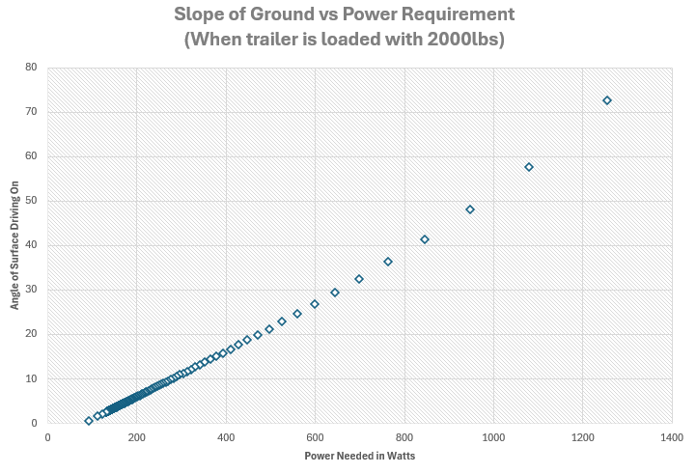
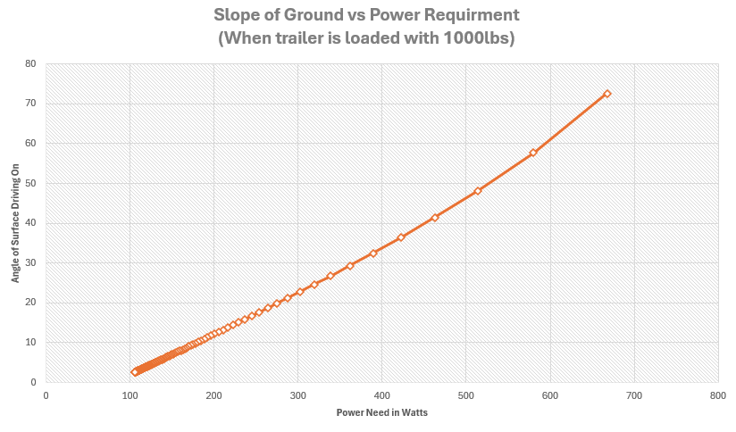
As shown in the 2,000 lb case, a slope of just over five degrees requires approximately 200 W of mechanical power. For the 1,000 lb case at approximately the same slope, the required power is just over 100 W. These calculations were used as the basis for selecting the drive motors. The selected motors were rated at 250 W each and included integrated gearboxes, which reduced the need for additional mechanical design or gearbox modification. The motors were intentionally oversized to provide a design margin for drivetrain losses, surface variation, weather conditions, starting torque, and other real-world inefficiencies.
A standard off-the-shelf trailer tongue jack was selected as the base structure for the project. This helped ensure that the system would properly interface with a tongue-style trailer without requiring a fully custom mounting design.
After the motors were selected, the motor driver requirements could be determined. The driver needed to support the required motor voltage and current while allowing independent control of both motors. A dual-channel motor driver was selected to reduce the overall footprint of the electronics and simplify the wiring compared to using two separate motor drivers.
Once the motor driver was selected, the microcontroller was chosen based on the need to provide pulse-width modulation, direction control, and communication with a phone app interface. The ESP32 microcontroller was selected because it provides a 240 MHz clock speed, Bluetooth Low Energy, Wi-Fi capability, and a large number of I/O pins. These features provided multiple options for wireless communication and real-time motor control.
With the motors, driver, and microcontroller selected, the power system requirements were defined. The motors required 24 VDC, the motor driver supported an input range of 12 VDC to 48 VDC, and the microcontroller required 5 VDC. To meet these requirements, two 12 V deep-cycle batteries were wired in series to provide the 24 VDC motor supply. A 24 VDC to 5 VDC step-down converter was then used to power the ESP32 from the same battery system.
Finally, additional components were selected to improve functionality beyond the minimum viable product. A relay was added to support active braking instead of relying only on passive braking when the system is powered off. An already owned weatherproof enclosure was used to protect the electronics and allow the system to be used in outdoor conditions. The deep-cycle batteries were chosen not only because they met the voltage and current requirements, but also because they were already available, helping reduce the project cost.
Overall, the design choices were made to balance performance, simplicity, cost, and mechanical compatibility with a standard tongue-style trailer.
3.2 Level 0
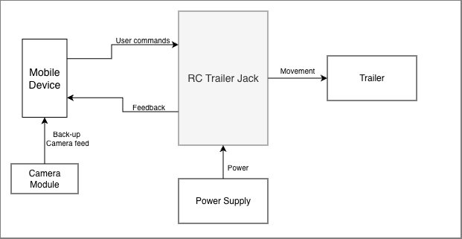
Figure 3: Level 0 Diagram

Module | RC Trailer Jack
Inputs | - Power: Constant DC voltage  - User commands: From the mobile app, the user can command throttle and direction
Outputs | - Movement: The motors and wheels generate movement to mobilize the trailer
Functionality | The module moves a trailer based on the real-time throttle and direction commands that the user prompts in the mobile app
Table 6: Level 0 RC Trailer

3.3 Level 1
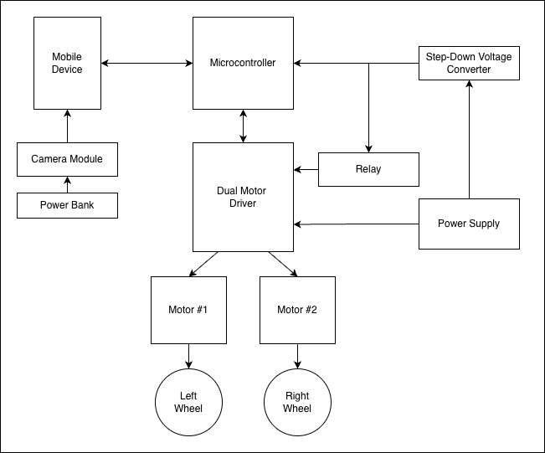
Figure 3: Level 1 Diagram

Module | Microcontroller
Inputs | - Power: 5 VDC from the step-down voltage converter  - User Commands: Throttle and direction commands from the smartphone
Outputs | - Motor Driver Commands: Tells the motor driver which motor to command and at what power rating
Functionality | Receives throttle and direction commands from the smartphone, calculates the necessary power for each motor, and delivers the power commands to the dual motor driver
Table 7: Level 1 Microcontroller

Module | Mobile Device
Inputs | - Camera Feed: Receives the feed from the back-up camera to display in the app  - Feedback: Receives feedback from the microcontroller to display to the user
Outputs | - User Commands: Throttle and direction commands to the microcontroller
Functionality | The user can command the throttle and direction of the RC Trailer Jack in app. They can also view the back-up camera feed to assist with parking.
Table 8: Level 1 Mobile Device
Module | Motor Controller
Inputs | - Signals: Four wires from Microcontroller providing left and right wheel direction and PWM signals  - Power: 24VDC from power supply
Outputs | - Left Motor Command: Left motor direction and PWM signal  - Right Motor Command: Right motor direction and PWM signal
Functionality | This provides the physical signal to both motors enabling smooth movement throughout operation.
Table 9: Level 1 Motor Controller
Module | Power Supply
Inputs | - None
Outputs | - Power: 24 VDC
Functionality | Supplies power to the system.
Table 10: Level 1 Power Supply
Module | Step-Down Voltage Converter
Inputs | - Power: 24 VDC
Outputs | - Power: 5 VDC
Functionality | Reduces the power from the batteries from 24 V to 5 V to prevent the components that require less power from burning up.
Table 11: Level 1 Step-Down Voltage Converter
Module | Motors & Wheels
Inputs | - Voltage: The motor driver supplies the output voltage to determine how fast the motors turn the wheels.
Outputs | - Movement: The rotation of the wheels generates movement to propel the trailer in the user’s commanded direction and speed.
Functionality | The motors rotate the wheel at the commanded speed to generate movement.
Table 12: Level 1 Motors & Wheels
Module | Relay
Inputs | - Power: 5VDC  - Signal: 3VDC signal
Outputs | - Open Contact: 24VDC power removed from electromechanical brakes
Functionality | The electromechanical brakes are fail-safe. Preventing operation if power is lost to the braking system. Control of the relay allows for safe parking and prevention of undesired or inadvertent movement.
Table 13: Level 1 Relay

3.4 Bill of Materials
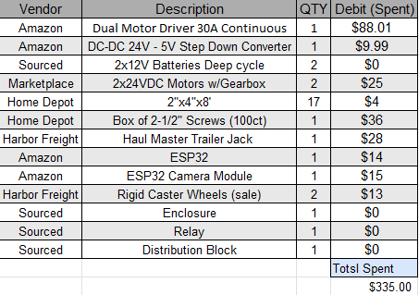
Table 14: Bill of Materials

- Software Design

5. Design Verification
5.1 Component Unit Testing
We conducted unit testing on our electrical components to verify functionality.
Component | Procedure | Results
DC Motors | Test resistance of internal windings | R_{right} = 0.7 Ω  R_{left} = 0.5 Ω
 | Test resistance of electronic brake | R_{right} = 43.6 Ω  R_{left} = 46.1 Ω
Power Supply | Measure output voltage | V = 23.9 V
Voltage Converter | Measure input and output voltage to verify functionality | V_{in1} = 12 V | V_{out1} = 5.29 V  V_{in2} = 24 V | V_{out2} = 5.29 V
Relay
Table X: Component Unit Testing

5.2 System Testing
5.2.1 Full-Scale Trailer Testing
We tested speed and maneuverability on a medium-sized utility trailer that we borrowed from a friend. Here are the results:
- We achieved the desired speed of 1 mph.
- Maneuverability was limited due to the structure of the trailer tongue.
- Successful movement with load of ~600 lbs in addition to the trailer weight.
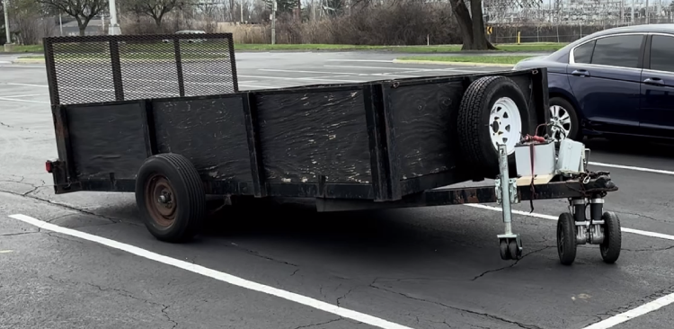
Figure X: Testing the RC Trailer Jack on a utility trailer

5.2.2 Mock Trailer Testing
We tested speed and maneuverability on the small mock trailer that we constructed ourselves. We achieved the desired speed of 1 mph. Here are the results:
- We achieved the desired speed of 1 mph.
- Full maneuverability was achieved due to the structure of the trailer tongue.
- Successful movement with load of ~200 lbs in addition to the trailer weight
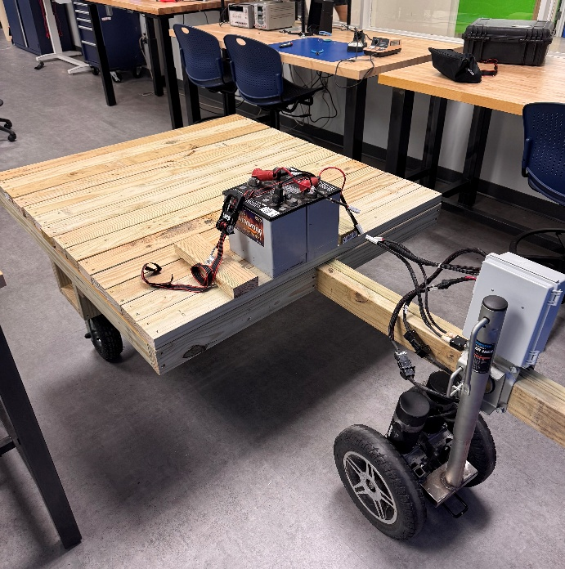
Figure X: Testing the RC Trailer Jack on the mock trailer

5.3 Engineering Target Evaluation
Goal | Outcome | Rationale for Failure  (if applicable)
Trailer jack must be able to move a trailer with a load of at least 500lb. | Success
Trailer jack must be able to move a trailer at a speed of approximately 1 mph. | Success
The hardware portion of the product should operate at a continuous duty cycle of at least 10mins. | Success
The hardware system should only require a power supply of 12VDC. | Failure | We used previously owned batteries to cut costs. The increased power actually cut our power losses.
The microcontroller should be able to communicate with the smart phone with maximum range of at least 30ft. | Success
Product must be able to bolt up to straight tongue trailers and capable of storage during vehicle towing | Success
6. Project Schedule
6.1 Gantt Chart
Milestones &  Deliverables | Planned Date | Forecasted Date | Actual Date | Status | Notes
Draft new Bill of Materials | 1/21 | 1/29 | 2/2 | Complete
Order parts for first prototype | 1/26 | 2/3 | 2/6 | Complete
Unit test motors | 1/29 | 2/5 | 2/5 | Complete | Tested with power supply
Resistance test motors | 2/10 | 2/12 | 2/18 | Complete
Test TX/RX of text-based data between ESP32 and smartphone | 2/09 | 2/13 | 2/12 | Complete
Verify functionality of Motor Driver | 2/16 | 2/26 | 2/24 | Complete | Didn’t test with relays
Test TX/RX of various types of data between ESP32 and smartphone | 2/16 | 2/24 | 2/26 | Complete
Attach motor driver to hardware | 2/23 | 3/10 | 2/26 | Complete
Construct electronics enclosure | 2/24 | 3/10 | 3/10 | Complete
Construct Mock Trailer | 2/24 | 3/5 | 3/7 | Complete | Need to adjust dimensions
Finish MVP hardware | 2/24 | 3/12 | 3/12 | Complete
Properly attach MVP to mock trailer | 2/24 | 3/19 | 3/17 | Complete | Rough connection complete for testing purposes
Complete first iteration of mobile app | 3/10 | 3/19 | 3/19 | Complete
Test MVP on mock trailer with app | 3/10 | 3/24 | 3/25 | Complete | Completed on prototype mock trailer
Test MVP on real trailer with app | 3/10 | 3/31 | 3/31 | Complete | Filmed portion of demo as well
Finish construction of final mock trailer | 3/23 | 4/9 | 4/9 | Complete
Attach Reverse Camera | 4/7 | 4/14 | 4/21 | Complete
Test MVP on final mock trailer | 4/6 | 4/14 | 4/16 | Complete
Table X: Gantt Chart
7. Summary and Conclusions
7.1 Summary
Using the techniques and materials listed in this report, a Remote Control (RC) Trailer Jack and compatible smartphone app were developed and constructed. The overall project demonstrated successful results and all requirements were either met or given a rationale for their unfulfillment. Our project earned first place in the KEEN Award competition for our successful MVP and presentation.

7.2 Future Improvements
If we were to continue development, we would prioritize the following improvements:
- Using an additional camera and a ML model, the trailer would be capable of self-parking and hitching up to the trailer
- The attachment hardware would be compatible with multiple trailer styles
- The battery sizes would be reduced
- The placement of the motors would be improved, i.e., positioned horizontally to the ground

8. References
- Cytron Technologies. (n.d.). SmartDriveDuo Arduino examples. GitHub. https://github.com/CytronTechnologies/Cytron_SmartDriveDuo/tree/master/examples

- Espressif Systems. (n.d.). CameraWebServer example for ESP32 Arduino core. GitHub. https://github.com/espressif/arduino-esp32/blob/master/libraries/ESP32/examples/Camera/CameraWebServer/CameraWebServer.ino

